QZB-700N Automatic Rice Packaging Machine

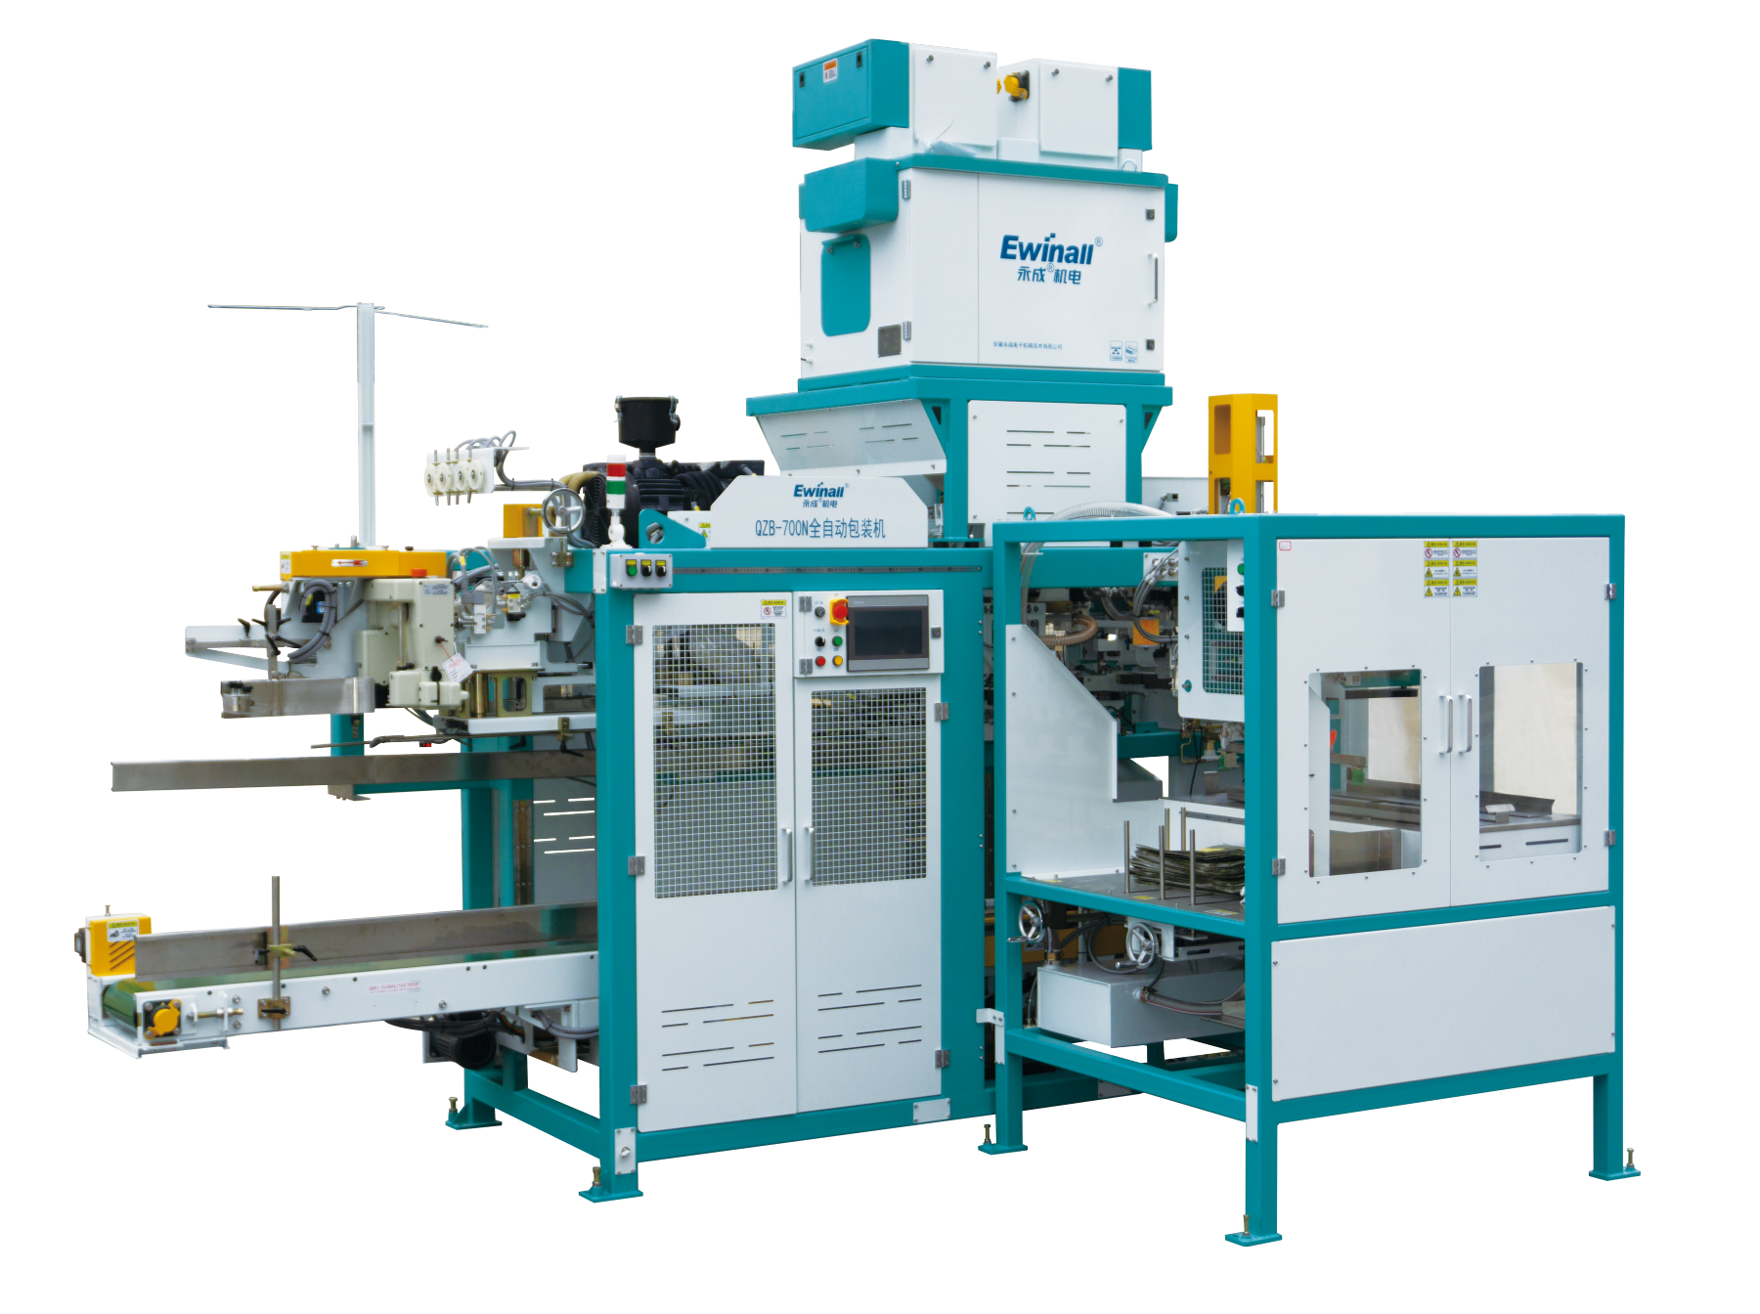

Technical Description

1. Equipment Composition
- Automatic Weighing and Packaging Scale
- Sliding Trolley Assembly
- Bag Sewing Machine Assembly
- Automatic Lifting Conveyor
- Packaging Machine Control System
- Automatic Bag Feeding Machine

2. Working Principle / Process Flow
Bag Feeder → Automatic Bag Supply → Material Feeding → Automatic Weighing Scale → Automatic Metering → Automatic Bagging Machine → Automatic Bag Opening → Automatic Material Filling → Packaging Conveyor → Bag Sewing → Finished Product Conveyor



Bag Feeder

Automatic Bag Supply

Automatic Weighing Scale

Automatic Bag Supply

Material Feeding

Automatic Bag Opening

Automatic Bagging Machine

Automatic Material Filling

Packaging Conveyor

Bag Sewing

Finished Product Conveyor

3. Main Technical Characteristics
The machine is designed for fully automatic packaging to improve efficiency, reduce labor requirements, and provide reliable and easy operation.

4. Product Data and Operating Conditions
Packaging Material: Rice or other free‑flowing granular materials.
Material Temperature: ≤ 50°C
Flowability: Normal / Good
During the filling process, the bag supporting mechanism lifts the support plate to hold the bag and bear the weight of the material. After filling, the bag clamping plates hold the filled bag, flatten the bag mouth, and the sliding trolley transfers the bag to the bag mouth shaping station.

5. Bag Mouth Shaping
The bag mouth shaping mechanism guides the filled woven bag to the finished product conveyor and then to the sewing station. The guiding belt is driven by a servo motor to match different conveying speeds and sewing requirements.

6. Control Panel
All machine operations are controlled via the central control panel, including start/stop, alarm monitoring, and parameter adjustment.

7. Interlocking Protection System
- Bag shortage alarm: system switches bag magazines automatically and triggers alarm.
- Low air pressure protection: machine stops when air pressure is below preset value.
- Bag clamping and opening detection: improperly opened bags are automatically blown out.
- Thread break detection: sewing machine alarms and stops the packaging system.
- Safety door protection: machine stops automatically when safety door is opened.

8. Sewing Machine
The sewing unit consists of an automatic bag guiding system, industrial sewing machine, thread break detection device, and electrical control system. Filled bags are automatically guided to the sewing position for bag mouth stitching and automatic thread cutting.

9. Technical Specifications
- Bag Weight Setting: 2.5-25kg (QZB-700N)
- Packaging Speed: 500–600 bags/hour (based on rice test data)
- Bag Type: Open‑mouth woven polypropylene bags
- Reference Bag Size: Length 750–1050 mm; Width 380–600 mm
- Ambient Temperature: 0–40°C
- Relative Humidity: Max. 90%
- Air Consumption: 600 L/min (0.5 MPa)
- Installed Power: 11 kW
- Machine Dimensions (L × W × H): 3750 × 2950 × 3850 mm

10. Main Components and Brands
No. | Component | Brand | Category
1 | PLC (Controller) | Omron (Japan) | Electrical
2 | Touch Screen | Kunlun Tongtai (MCGS) | Electrical
3 | Low-voltage Electrical Components | Eaton (Germany) | Electrical
4 | Photoelectric / Proximity Sensors | Turck & SICK (Germany) | Electrical
5 | Vacuum Pressure Switch | SMC (Japan) | Electrical
6 | Weighing Load Cell | Toledo (USA) | Electrical
7 | Relay | Moeller | Electrical
8 | Vacuum Suction Cup | Customized Design | Mechanical
9 | Pneumatic Cylinder | SMC (Japan) | Pneumatic
10 | Solenoid Valve | SMC (Japan) | Pneumatic
11 | Servo Motor | Delta | Electrical
12 | Planetary Gear Reducer | Kefeng (China) | Mechanical
13 | Bearings | C&U | Mechanical
14 | Vacuum Pump | Zhongde | Mechanical

