QZB-600M AUTOMATIC PACKING MACHINE

PRODUCT DESCRIPTION
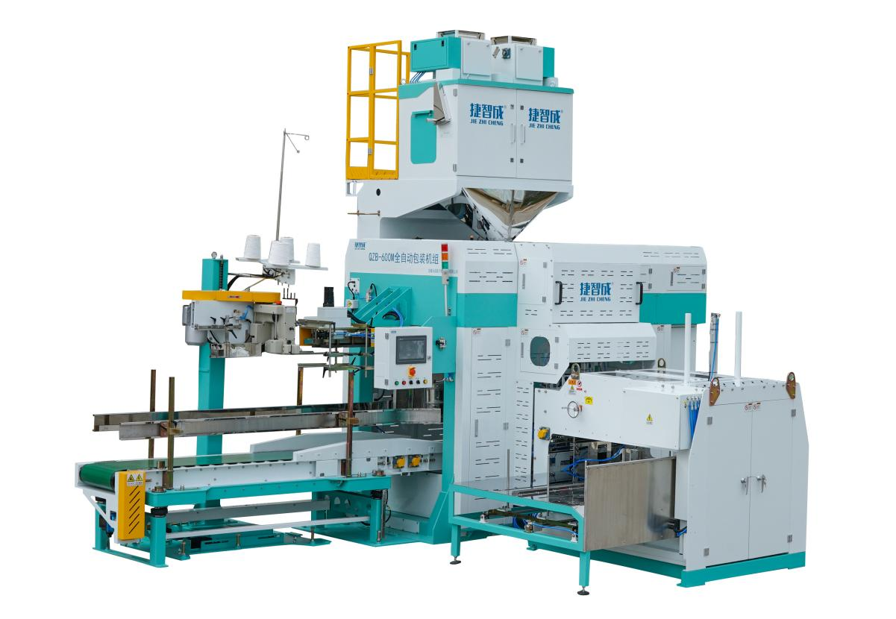

1、 Equipment components
The main components of the automatic packaging unit:
- Automatic packaging scale (optional)
- Pulley assembly
- Bag sewing machine assembly
- Automatic lifting conveyor
- Packaging unit control system
- Bag feeding machine assembly

2、Working principle flow chart



Automatic bag feeding

Automatic weighing

Packing scale

discharge

Automatic bag opening

Send bag

Bag feeding machine

Automatic unloading

Package delivery

Sewing Machine

Finished product delivery

3、Main technical performance of packaging unit
1、The main basis of the design:
automatic packaging, improving efficiency, saving manpower, and convenient operation.
2、Product data, packaging materials and equipment operating conditions
（1）Name of packaging material: rice and other granular materials with good fluidity
— Packing temperature: material temperature is less than 50°C
— Liquidity: general
（2）Capacity of stand-alone packaging system:
Set per package: (25～50) kg
Packing speed: (500～600) packs/hour (test data is rice)
（3）Packaging bag requirements:
Type: open type
Packaging material: non-coated woven bag, non-film woven bag requires a flat bag shape, no corners, no bending, no folding and wrinkling, no adhesion at the bag mouth, and the bag mouth is rubbed through the bag-making process with rubbing mouth The woven bag with the bag mouth; double-sided coated woven bag, the woven bag requires double-sided film, the bag mouth is a cold-cut woven bag, and the bag is flat and free of folds and wrinkles.
Dimensions: Length: (750～110) mm
Width: (450～550) mm
Weight: 25kg/50kg≥50g/90g
Packaging bag reference size:
25kg: 450mm×850mm (length×width)
50kg: 550mm×110mm (length×width)
Note: The width dimensions of the bags given do not include the M side.
（4）Equipment operating conditions
Ambient temperature: (0～40)℃
Humidity: up to 90%
（5）Air consumption: 533L/min (0.5MPa)
（6）Power: 5.5kw
3、Description of main components
3.1 Composition of packaging machine
a. Bag feeding machine
There are 2 horizontally arranged bag storages, and the bag feeding device is supplied to the equipment by the suction cup bag picking device. When the empty bags of one unit are taken out, the empty bag warehouse of the next unit is automatically switched to the bag picking position to ensure the continuous operation of the equipment.
b. Bag feeding device
The bag feeding mechanism is mainly to complete the pre-opening of the woven bag placed horizontally on the bag preparation platform during the continuous production process and clamp it up and turn it 90 degrees to the station of the bag clamping mouth and bag opening mechanism. After the bag is clamped, the bag feeding mechanism resets, and so on.
c. Door retraction and bag opening device
When the bag feeding device transports the woven bag to the bag clamping station, the servo bag feeding device rotates 90° to the opening of the door and sends out a signal of completion of bag feeding. A clip holds both sides of the pocket. At the same time, the bag opening cylinders on both sides act at the same time, and the door opening device opens the bag to start unloading.
d. Bag holding device
During the material filling process, the supporting plate of the bag holding mechanism moves upward to hold the bag and bear the packaging weight of the material. After the material is filled, the movement of the holding board will hug the filled bag, and at the same time, the clamping board will flatten the mouth of the bag, and then push the cylinder to move the bag from the unloading station to the jaw for shaping.
e. Jaw shaping
The main function of this mechanism is to introduce the woven bags filled with materials to the finished product conveyor and enter the sewing station. The pinch shaping guide belt is driven by a servo motor to meet the needs of different speeds and sewing bags.
f. Control panel
All the actions of the packaging machine are controlled on this panel.

3.2 Packaging machine interlock
- Alarm for bag shortage in bag feeding machine
When the woven bags in the bag storage of the bag supply machine are used up, the program controls the automatic replacement of the bag storage, and at the same time the indicator light and buzzer will alarm and display. If the bags are not supplied in time when all the woven bags are used up, the packaging unit will automatically stop working.
- Insufficient air pressure
When the air pressure is lower than the set value, the packaging machine stops working. At the same time, the indicator light and buzzer alarm.
- Pouch and open bag
When the empty bag is not clamped or the mouth of the bag is not fully opened, the empty bag that failed to be loaded is automatically blown out of the bagging area.
- Disconnection
Alarm for sewing bag thread breakage. At the same time the packaging machine stops.

e. Safety door switch

The packaging machine stops automatically when the safety door is opened.

3.3 Sewing machine
Function: This device is composed of automatic induction, sewing machine, thread break alarm, electrical control system, etc. The bags filled with materials are imported by the automatic import system through the conveyor, automatically sewed, and automatically trimmed. If there is a broken thread, the control system of the sewing machine will automatically alarm and send an interlock stop signal.下·

Features
1、Fully automatic packaging machine. After the equipment manually places the packaging bag, it can realize automatic bag feeding, automatic bag loading, automatic bag opening, automatic detection, automatic weighing, automatic filling, and automatic sealing of the packaging bag, with a high degree of automation.
2、The specially developed woven bag feeding machine, patented technology, can quickly, stably and reliably supply bags to the packaging machine.
3、Friendly man-machine interface design, using touch screen, PLC programmable control system, man-machine interface display operation is more clear and convenient, more humane. The equipment has a fault self-diagnosis function, and faults can be quickly eliminated according to the touch screen prompts.
4、The equipment has high safety, adopts a closed structure, and is equipped with an interlocking device. If a worker enters the equipment, the equipment will automatically stop and give an alarm. The equipment can only be restarted after manual confirmation and reset.
5、Patented bag opening technology for woven bags, combined with high-flow vacuum adsorption, stable and reliable bag opening.
6、The transmission mechanism adopts the method of servo motor and gear transmission to ensure that each action is flexible, accurate and fast.
7、The automatic lifting conveyor adopts single-point driving and four-point vertical lifting, with a wide range of lifting heights, precise and stable lifting, and strong carrying capacity.
8、The weighing system adopts an advanced measurement structure, specially designed three sensors, and a scientific and reasonable layout, so that the weighing bucket is reasonably stressed, which greatly improves the stability and anti-interference ability of the equipment.

5、The main configuration list
No. | Parts name | Brand | Category
1 | PLC | Omron (Japan) | Electrical part
2 | Touch screen | Delta (Taiwan) | Electrical part
3 | Low voltage electrical | Eaton (Germany) | Electrical part
4 | Limit switch | Omron (Japan) | Electrical part
5 | Photoelectric/  proximity switch | Turck (Germany) and Sick (Germany) | Electrical part
6 | Vacuum pressure switch | SMC (Japan) | Electrical part
7 | Load cell | HBM (Germany) | Electrical part
8 | Relay | IDEC (Japan) | Electrical part
9 | Vacuum suction cup | Homemade with special craft | Mechanical part
10 | Cylinder | AirTAC (Taiwan) | Mechanical part
11 | The electromagnetic valve | SMC (Japan) | Mechanical part
12 | Servo motor | Delta | Mechanical part
13 | Planetary reducer | Delta or Hubei Kefeng | Mechanical part
14 | Bearing | C&U | Mechanical part
15 | Vacuum pump | ZD | Mechanical part

